**Lab 16 – Sickle Cell Genetics**

**Background and Significance**

Sickle cell disease is an inherited genetic disorder that causes significant health problems including low numbers of red blood cells (**anemia**), repeated infections, and episodes of pain due to blood vessel blockages. The root cause of these symptoms is a structural change in hemoglobin causing the red blood cells to form sickles. Hemoglobin is a tetramer made of four smaller polypeptide protein chains (two subunits of alpha-globin and two subunits of beta-globin) that come together to make the final protein. Each subunit can bind to one oxygen molecule and distribute oxygen throughout the body.

**A Single Amino Acid Substitution Leads to Sickle Cell Disease**

A simple **substitution** of just one amino acid in the beta-globin subunits of the hemoglobin protein leads to sickle cell disease. One **hydrophilic** amino acid (glutamic acid) is replaced by a **hydrophobic** amino acid (valine) in the sixth position of the beta-globin polypeptide chain. This change of valine for glutamic acid does not change the overall structure of the molecule, but it does mean that a single hydrophobic amino acid is now facing out in direct contact with water on the outside of the hemoglobin protein. Hemoglobin changes conformation when it is bound to oxygen. Hemoglobin proteins will start to form long chains inside the red blood cell, joined together by hydrophobic valine amino acids. When these chains become long enough, they can distort the shape of the red blood cell, giving them their namesake sickle shape. This distorted shape is what can cause so many health problems for the individual.



The spleen may recognize sickled cells as abnormal and remove them from the body, lowering the overall red blood cell count and the average lifespan of RBCs, causing anemia. Sickled cells are less elastic than regular blood cells, further causing the cells to become stuck in capillaries leading to blockages called sickle cell crises. These crises can be incredibly painful and may lead to permanent tissue damage in the area where the blockage occurs. Individuals with sickle cell disease also may have reduced spleen function, contributing to increased rates of serious infection.

**The Genetic Inheritance of Sickle Cell Disease**

Sickle cell disease inheritance is **autosomal** **recessive**, meaning a person must be **homozygous** (have two copies of the sickle cell allele (HbS)) to be affected. People who have either one or two copies of a normal beta-globin (HbA) allele will not be sick with sickle cell disease. **Heterozygous** individuals do not usually show signs of sickle cell anemia but have the sickle cell trait and still produce some abnormal beta-globin. Because there is normal beta-globin present, long chains that form in sickle cell disease patients will generally not form in those with sickle cell trait. These individuals may experience some symptoms of sickle cell disease in extreme cases of prolonged low oxygen.

**Prevalence of Sickle Cell Disease**

Sickle cell anemia is most often found in sub-Saharan Africans and their descendants; however, it is found at lower frequencies in some areas of the Middle East and regions of India. The distribution of sickle cell alleles reflects the historical distribution of the infectious disease malaria, which is transmitted by mosquito bites. This relationship is due to sickle cell alleles conferring some malarial protection. Migration has brought the sickle cell allele worldwide. In the United States, approximately 1 in 100,000 babies will be born with sickle cell disease, but in African Americans the number of sickle cell births is much, much higher, approximately 1 in every 365 births. It is estimated that 1 in every 13 African Americans has the sickle cell trait ([https://www.cdc.gov/ncbddd/sicklecell/data.html.](https://www.cdc.gov/ncbddd/sicklecell/data.html))

**Testing for sickle cell disease**

In all states, newborn babies are routinely tested for sickle cell anemia as part of normal newborn screening procedures. Patients with confirmed positive testing will be referred to a hematologist for genetic testing in consultation with a genetic counselor. Genetic testing for sickle cell may be done using polymerase chain reaction (PCR) and restriction digestion. The mutation that causes the change from normal beta-globin to the sickle cell variant happens to be in the middle of a restriction enzyme recognition site. The normal beta-globin allele has the sequence CTGAG from nucleotides 17-21 of its coding region. CTGAG happens to be the recognition sequence for the enzyme DdeI. When DNA containing this sequence is incubated with the DdeI enzyme at 37˚C, the enzyme cuts the DNA in two. In the sickle cell allele, the adenine (A) in the sequence is changed to thymine (T), meaning the sequence is now CTGTG. This means that the enzyme cannot cut the DNA into two fragments in the sickle cell allele. The difference in whether the DNA was cut or not can be observed on an electrophoresis gel.

**Today’s lab**

In today’s lab, you will analyze DNA samples from a family of four who were referred for genetic testing for genetic testing for sickle cell anemia. You have been provided with a 400 bp PCR product from the beta-globin gene incubated in the presence of the restriction enzyme DdeI at 37˚C. You must run the DNA samples on an electrophoresis gel to determine whether the family members carry the sickle cell mutation and if they are affected by sickle cell disease or sickle cell trait.

|  |  |
| --- | --- |
|  | Expected band lengths |
| Normal Hemoglobin | 150, 250 |
| Sickle Cell Trait | 150, 250, 400 |
| Sickle Cell Disease | 400 |

**Patient medical histories**

* **Robinson family:** The Robinson family was referred to genetic testing and counseling after Marie, their infant daughter, was identified in routine infant screening as likely having sickle cell disease.
* **Jacqueline (Mother):** Jacqueline is a 32-year-old female born in Port-au-Prince, Haiti. She immigrated to the US when she was 5 years old. She reports no abnormal medical history other than occasional migraine headaches. She has three surviving sisters, all of whom are in normal health. Jacqueline’s older brother died from pneumonia as a 1-year-old while living in Haiti. Jacqueline is of primarily African descent. Jacqueline has never been tested for sickle cell.
* **Cory (Father):** Cory is a 32-year-old male born and raised in the US. Cory reports nothing abnormal in his medical history. Cory is one of three children. He has two older sisters, both surviving, who also have nothing abnormal in their medical histories. Cory is of primarily African descent. Cory has never been tested for sickle cell.
* **Samuel (Child 1):** Samuel is a 4-year-old healthy boy. Jacqueline reports that her pregnancy with Samuel was normal and that he has had no major illnesses. Samuel did not show any abnormalities in his routine infant screenings.
* **Marie (Child 2):** Marie is 2 months old. Jacqueline reports that her pregnancy with Marie was normal. A pre-natal screening program found low levels of normal hemoglobin in Marie’s blood and she was referred to follow up testing. A second blood test was inconclusive.

1. **Prepare for gel electrophoresis – pouring and running agarose gels**
2. **Prepare the tank, buffer, and gel**

* Agarose gels should be prepared during the PCR run to allow the gels to solidify using the protocol in Appendix A.

1. **Add loading dye to PCR samples (if required)**

* Add 2.5 mL 6X loading dye solution to each sample, changing tips between each sample

1. **Load the ladder and your sample onto the gel in the following sequence. Exchange DNA samples with other classmates to put on your gel for comparison.**

* Lane 1: 8 μL 100 bp DNA Ladder
* Lane 2: 10 μL Jacqueline DNA
* Lane 3: 10 μL Cory DNA
* Lane 4: 10 μL Samuel DNA
* Lane 5: 10 μL Marie DNA

1. **Conduct electrophoresis.**

* Run the gel at 150 V for approximately 20-30 minutes, or until the colored dye has progressed to at least half the length of the gel
* Once electrophoresis run is complete, turn the power off and remove the gel from the box.

1. **Band size determination and interpretation**
2. **Place the gel on the transilluminator.**

* Wear UV protective goggles.
* For best viewing, dim lights.
* Gels may be viewed at the end of the run or periodically throughout the run.

1. **Verify the presence of PCR product.**

* Is there a band?

1. **Ensure there is sufficient DNA band resolution in the 200-400 bp range of the 1 Kb DNA Ladder**

* Run the gel longer if needed to increase resolution.
* DNA ladder should look approximately as shown.

1. **Compare the bands from the DNA samples to the ladder to obtain size estimates. Take a picture with a smartphone.**

* Estimate the size of the DNA fragments by comparing the Robinson family DNA samples to the molecular weight reference marker (DNA Ladder)
* To create an electrophoresis standard curve, use a metric ruler to measure the distance from the edge of the well to the center of each band in your DNA ladder (in millimeters).
* Plot each point on the two graphs below. For each graph, the X axis is the distance traveled by each band measured in millimeters. The Y axis is the size of the band in the DNA ladder. Note that the scales of the Y axes are different for the two graphs.
* Connect your points to make a curve/line.
* 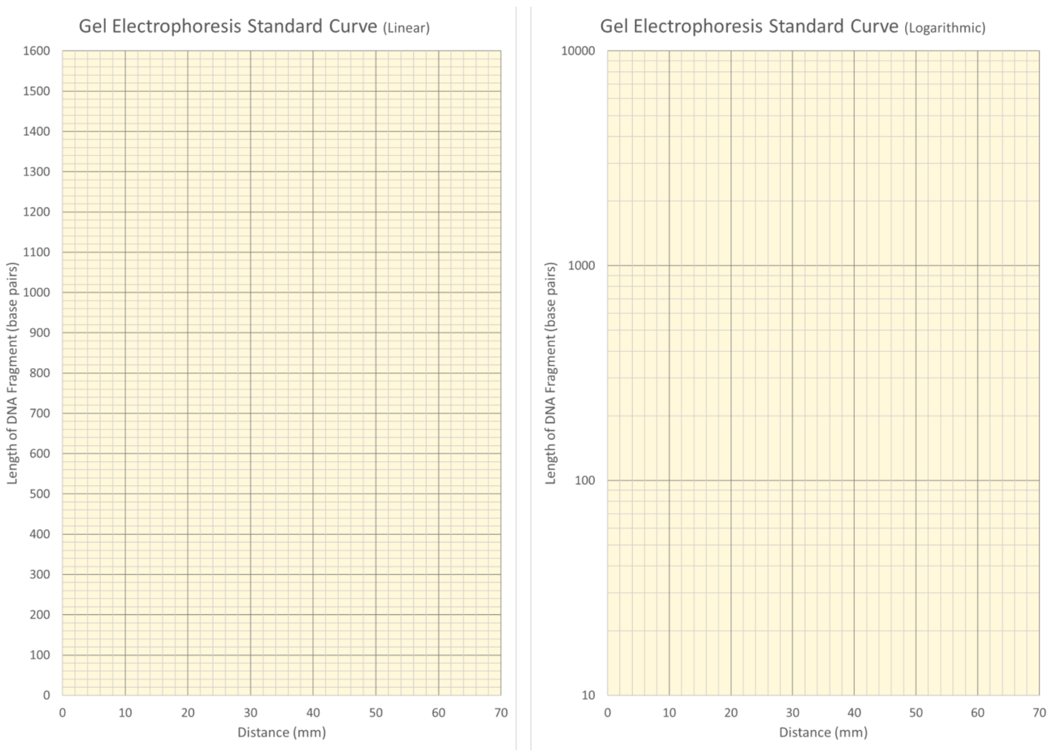To estimate unknown band size from your standard curve, pick one lane in your gel where there are three bands (an HbA/HbS heterozygote). Measure the distance each band traveled from the edge of the well. This distance represents the X axis value for the unknown band. Use the line that you drew to estimate the size of the unknown bands.

1. **Study questions**
2. After reading Jacqueline and Cory’s medical histories, do you see any risk factors for sickle cell?
3. Is it possible for Jacqueline’s brother to have died of sickle cell disease and no one else in her family to have the disease?
4. If Marie has sickle cell disease, what must we know about Cory and Jacqueline?
5. What is your genetic diagnosis of each member of the Robinson Family? State whether each family member has sickle cell disease, sickle cell trait, or is unaffected by sickle cell.

Jacqueline: Samuel:

Cory: Marie:

1. **Using Punnett squares and pedigree analysis.**

Use a Punnett square to answer the following questions. Use A to represent the normal ‘HbA’ allele and S to represent the sickle cell ‘HbS’ allele.

1. If two parents have the sickle cell trait, what is the chance that their child will have sickle cell disease?

|  |  |
| --- | --- |
|  |  |
|  |  |

|  |  |
| --- | --- |
|  |  |
|  |  |

1. If a person with sickle cell disease has children with a person who does not carry the HbS allele, can they have a child with sickle cell disease?
2. The following is a pedigree of the Robinson family that has not been filled in. Fill in the pedigree based on your data from the lab and add the rest of Jacqueline’s family onto the pedigree. Assume that Jacqueline’s brother was positive for sickle cell. Include every family member mentioned and fill in as much information as possible.

**Reference:**

* + 1. Adapted from miniPCR™ Sickle Cell Genetics Lab: Diagnosing Baby Marie Version: 1.0, Release: March 2018, © 2018 by Amplyus LLC